**CREATING, MERGING, DELETING BRANCHES**

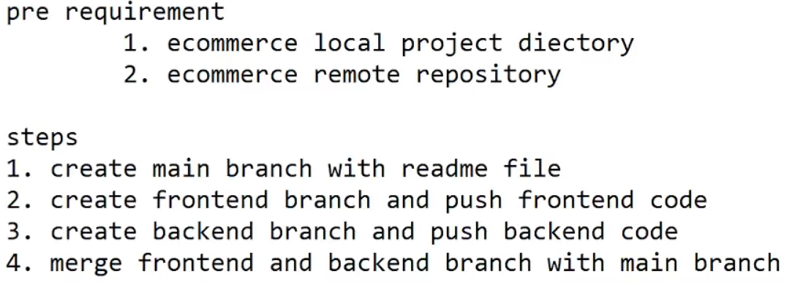

-Login GitHub from Local System (Only one time configuration)

$git config --global user.name "sunxxxx"

$git config --global user.email "sunxxxx@gmail.com"

=====================================================================

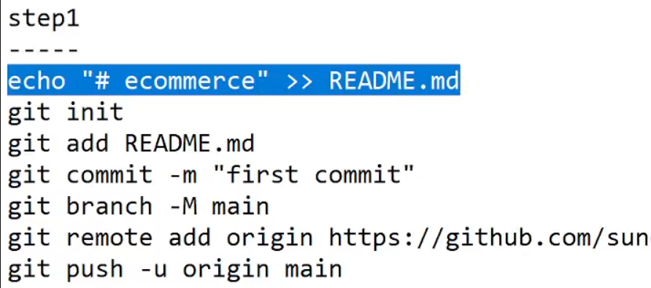

Now to create branches in GitHub as follow: We will see further steps

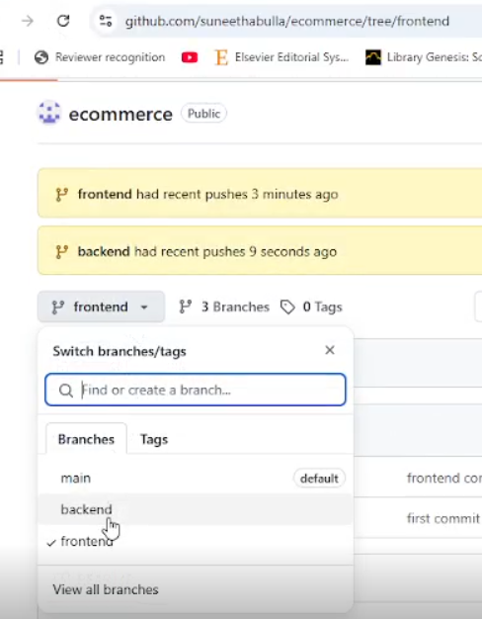

**(To create frontend branch and push)**

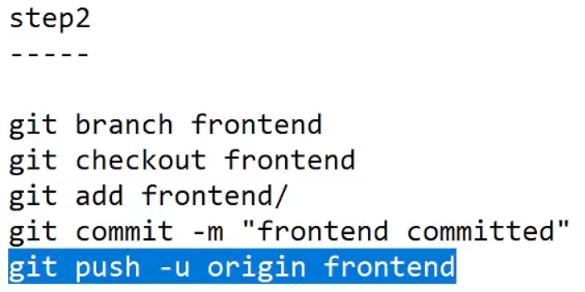

**STEP-3 (To create backend branch and push)**

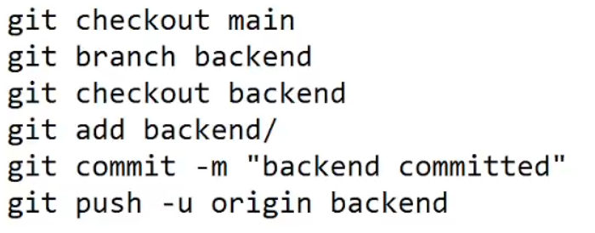

To Merge branches

step4

-----

git checkout main

git pull origin main # Ensure main is up to date

git merge frontend -m "Merged frontend into main"

git merge backend -m "Merged backend into main"

git push origin main

To delete branches

Git branch –d frontend //local delete if it merged only

Git branch –D frontend //local force delete

Git push origin - - delete frontend // remote delete

Git push origin - - delete backend

**CLONE**

**Git clone** [**https://github.com/lakshminarayana-kodavali/Gitclass1.git**](https://github.com/lakshminarayana-kodavali/Gitclass1.git)

**Removing Repo files**

git rm "temp.js"

git commit -m "Delete temp.js from main branch"

**Tagging**

Creates a **lightweight tag** named v1.0 on the **current commit**.

git tag v1.0

// Creates an **annotated tag** named v1.1 on the **current commit**.

git tag -a v1.1 -m "Release version 1.1"

git tag //list all tags

git show v1.0 //show tag details

git push origin v1.4 // pushes with release number.

git tag -d v1.0 //delete a tag

